Exp No : 1
Date : 08/02/2019
Aim : Getting started with Linux basic commands for directory operations, displaying directory
structure in tree format etc.
Command 1 : pwd (Print working directory)
Purpose of command : To know which directory you are in. This command gives the absolute path.
Usage : pwd
Sample I/p and Output

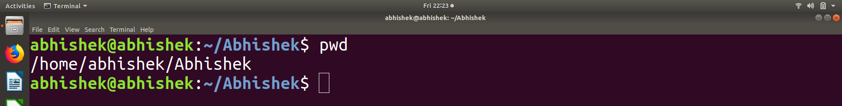
Command 2 : ls
Purpose of command : To know what files are in the directory.
Usage : ls
ls -a (To show hidden files)
Sample I/p and Output:
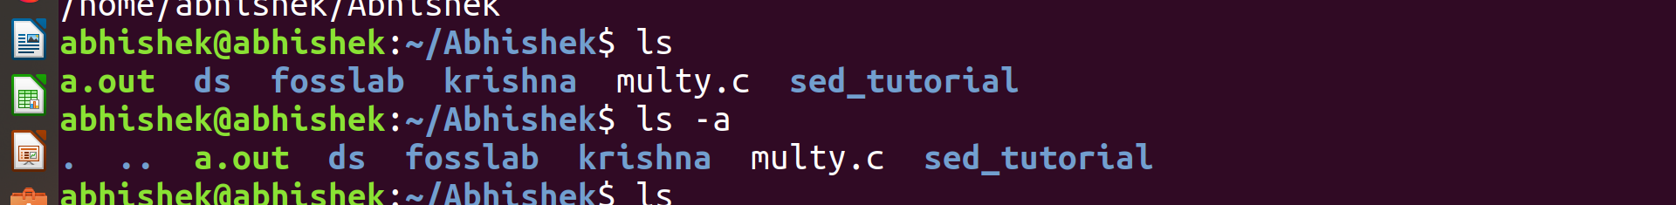

Command 3 : cd
Purpose of command : To go to a directory.
Usage : cd “filename”
cd .. (To go to the previous directory)
Sample I/p and Output: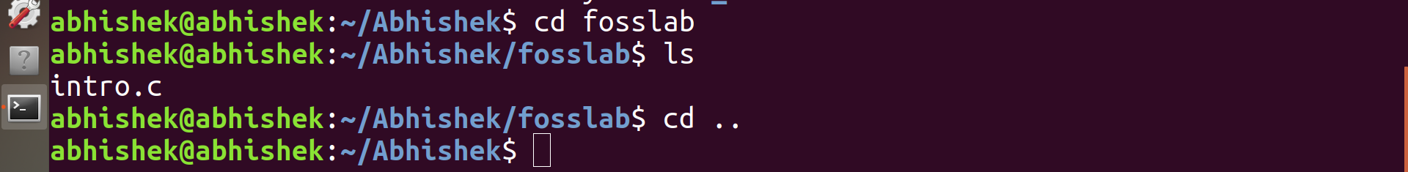
Command 4 :mkdir(make directory) ,rmdir (remove directory)
Purpose of command : mkdir =To make a directory, rmdir= To remove directory.
Usage : mkdir “Filename”
rmdir “filename”
Sample I/p and Output:
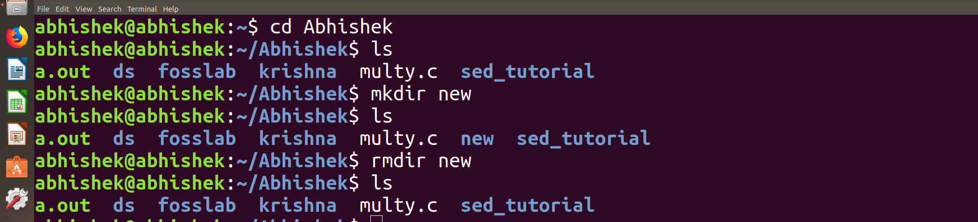
Command 5 : rm
Purpose of command : Delete files and directory.
Usage : rm “filename” (To remove a file)
rm -r “directory name” (To remove a directory)
Sample I/p and Output:
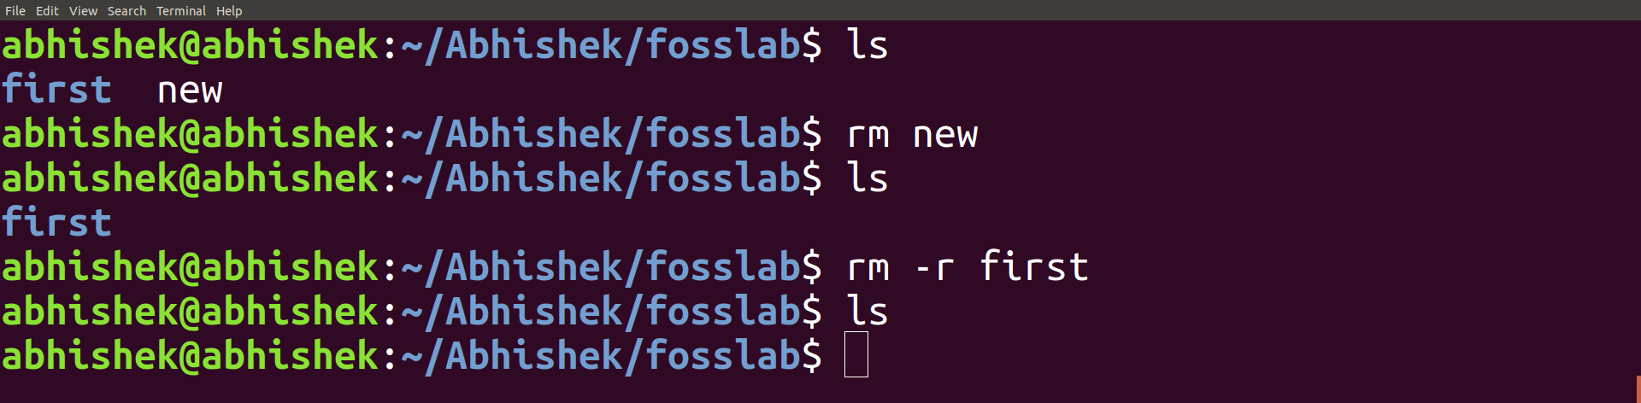
Command 6 : touch
Purpose of command : create a file.
Usage : touch “Filename”
Sample I/p and Output
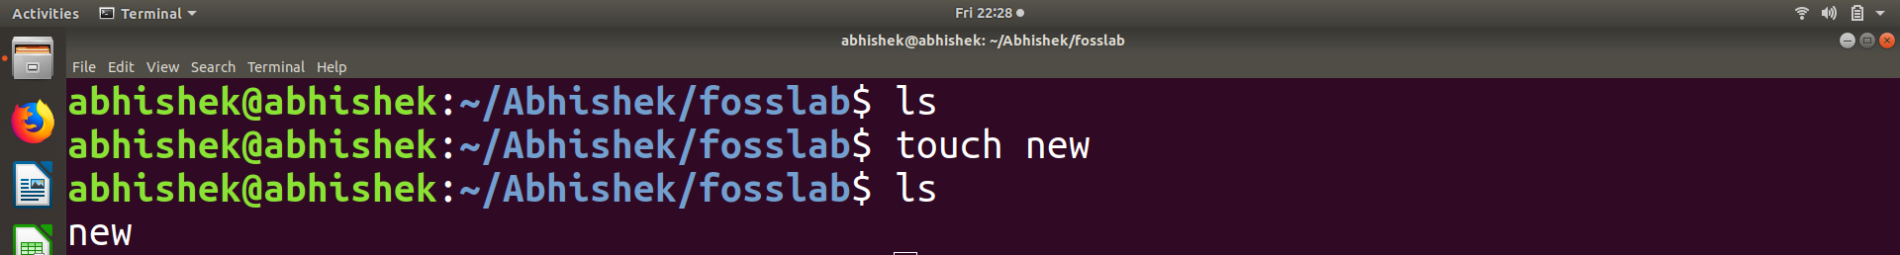

Command 7 : cp
Purpose of command : copy files through command line.
Usage :cp “location of the file to be copied” “where to copy”
Sample I/p and Output:
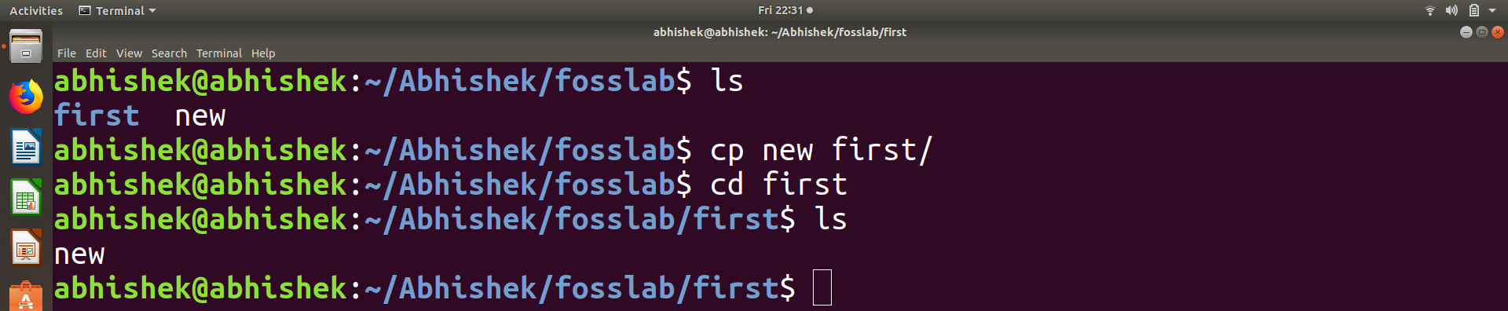
Command 8 : mv
Purpose of command : move files through command line.
Usage :mv “location of the file to be moved” “where to move”
Sample I/p and Output:
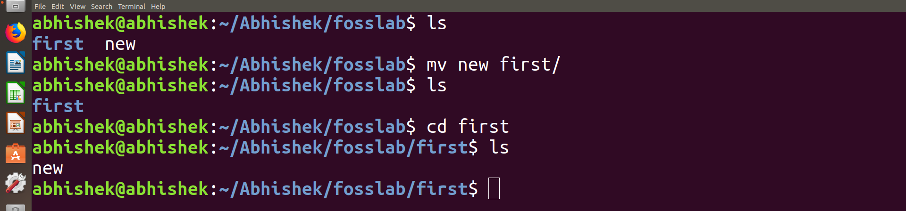

Command 9 : cat
Purpose of command : Display the content of a file
Usage : cat “filename”
Sample I/p and Output:
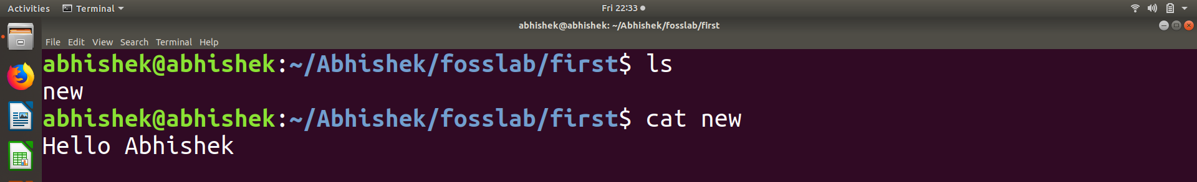

Command 10 : echo
Purpose of command : Help us move some data, usually text into a file.
Usage :echo “content” “filename”.
Sample I/p and Output:
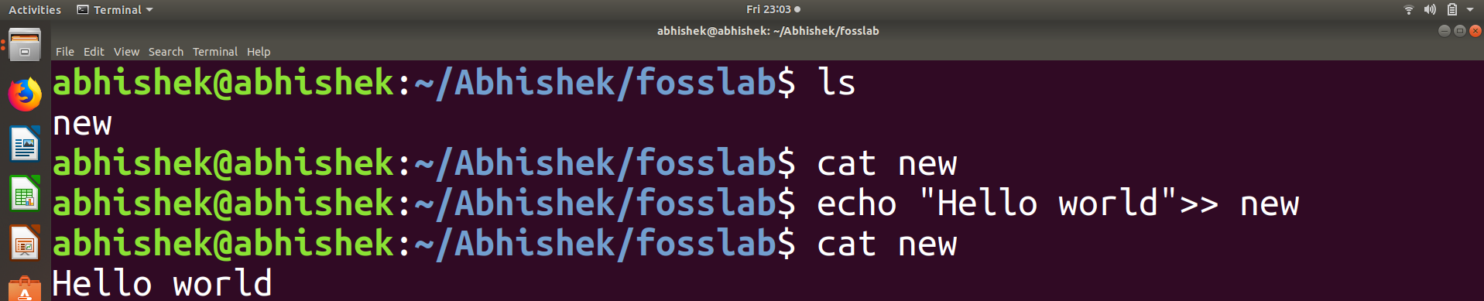

Command 11 : tree
Purpose of command : Tree is a recursive directory listing program that produces a
depth indented listing of files.
Usage : tree
Sample I/p and Output:

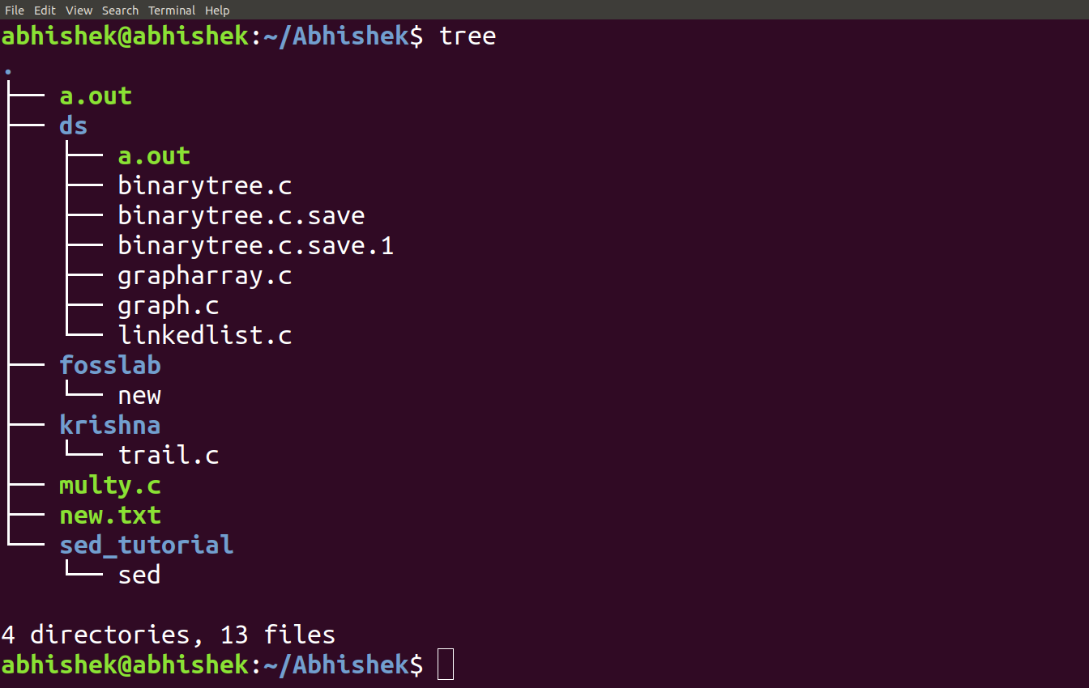
Command 12 : history
Purpose of command : Display the shell command history.
Usage :history n #where n is to see last n commands
Sample I/p and Output:

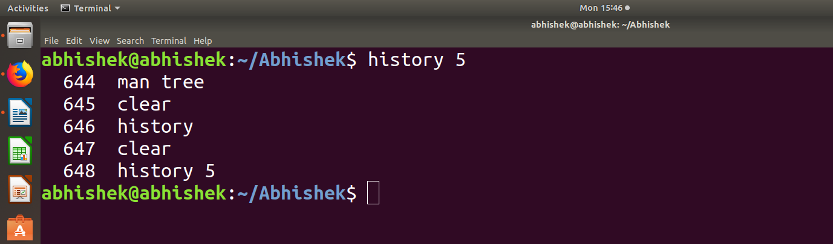

Conclusion
Linux basic commands like “cd”,”ls“ helps us to navigate through locations and other commands like “mv”,”cp”,”cat” helps us to do some basic operations. Also there exists a large number of basic commands which helps to improve user experience.

